Measuring the Nonalcoholic Fatty Liver Disease Possibility using Different Types of Deep Learning Algorithm

Abu Sufian

Daffodil International University

Dhaka, Bangladesh

[abu15-2700@diu.edu.bd](mailto:Faruqhossain15-2700@diu.edu.bd)

Farzana Akter

Daffodil International University

Dhaka, Bangladesh

[farzana15-2700@diu.edu.bd](mailto:farzana15-2700@diu.edu.bd)

Faruq Hossain

Daffodil International University

Dhaka, Bangladesh

[faruqhossain15-2700@diu.edu.bd](mailto:faruqhossain15-2700@diu.edu.bd)

***Abstract*— The Nonalcoholic Fatty Liver Disease (NAFDL) is a disease that can affect people who drink small amounts of alcohol. The main feature of a large amount of fatty NAFLD in liver cells. NAFLD is increasingly prevalent worldwide, especially in Western countries. In the United States, it is the most common from, of chronic liver disease affecting about one-fourth of the population. A recent study found an outbreak of fatty liver, a significant contributor to liver-related deaths, 33.66 precent or one-third of the adult population-indicating that more than 45 million Bangladesh have the disease. So, we need to be concerned about the risk of fatty liver Disease. If we cannot take appropriate stapes to diagnose fatty liver In, the early stages, we will eventually face serious health problems. In this study we have shown the relationship of differences Symptoms and disease that cause fatty liver so we can help a person to diagnose diabetes at an early stage. Nowadays, Deep learning classification methods are well adopted Researchers to develop patient risk forecasting models. So used in this study. In this paper different types of deep learning algorithms are used for measuring the fatty liver disease possibility. They are Convolutional Neural Networks, Long Short Term Memory Networks, Recurrent Neural Networks, Multilayer Perceptions. Finding the best algorithm with this paper also shows the correlation matrices, visualizes the feature, and AUC. This is all in the deep classified Deep learning has shown graded 71% best accuracy.**

*Keywords*—Liver Disease, Accuracy, Deep Learning, Prediction, Classifier.

# Introduction

Liver disease is a complex and congenital condition The susceptibility to numerous diseases is influenced by the development of a number of factors. It includes sexuality, ethnicity, genetics and exposure to the environment. Many people think that if they have fatty liver then all the complaints of indigestion or gastric related stomach are due to this disease but it is not correct at all. Alcohol consumption, in addition to this there are a few drugs that can make fat in the liver. In addition, viral infections such as hepatitis B and C can cause liver problems that can lead to increased liver fat. Blood sugar, obesity and high cholesterol are also some of the causes. We call this disease non-alcoholic fatty liver disease. In short we call it NAFLD

Fatty liver disease affects about 20% of the world population at this time. We care about fatty liver disease because it is a problem that can lead to liver failure, liver cancer and the need for a liver transplant. The presence of excess fat in the liver can lead to chronic irritation of the liver cells and subsequent further damage to the liver. There are three common causes of fatty liver disease, being overweight, diabetic, and patients with high cholesterol. Fatty liver disease was used as a very rare condition in children. The fat in the liver cells causes the cells to swell or become inflamed. We call it NASH stage non-alcoholic osteopathy. In the nasal stage where there is swelling in the cells, there may be gradual liver damage. Gradually when the liver becomes swollen, the scar appears and we call it scarring.

In most clinical trials, the most common causes of liver disease are considered to be between 25% and 45%. Significant evidence of hepatitis steatosis, as well as other factors in fat formation such as heavy alcohol use, long-term use of steatogenic drugs, and monogenic genetic diseases are all indicators of its existence. These

Contributing to the activation of the inflammatory environment which exacerbates heptachlor damage and causes part of its death

NAFLD patients develop cirrhosis but also have a risk of liver failure. There are several causes of non-alcoholic steatohepatitis (NASH). It is a type of NAFLD that evolved over time. The cheapest Prerequisites for histology to diagnose Nash include steatosis, lobular inflammation, and ballooning in the liver. This NAFLT disease is a non-alcoholic fatty liver disease. And those with obesity, high blood pressure, high cholesterol, diabetes, 0% of this population may have fatty liver problems.

If we talk about its symptoms, there are no symptoms at the initial stage. However, in about 10-15% of people it is seen that we have tightness or heaviness in the upper right part of the abdomen. Which may be due to this disease. There are no symptoms other than these, these are seen very late in the illness. Therefore, the disease needs to be diagnosed at a very early stage so that it can be treated. Nowadays fatty liver can be diagnosed through body checkups like ultrasound. Otherwise, if you do the abdominal ultrasound in favor of the kidneys too, too much fatty liver can be diagnosed. A biopsy can be done to diagnose and measure the severity of a disease. Liver that contains more than 5% fat is considered abnormal. Although liver biopsy is now considered the gold standard for evaluating NAFLD and NASH activity, it is still used aggressively. In addition, based on visuals Calculating these discoveries is complex and time consuming.

There are recent studies that confirm the benefits of coffee for patients with liver disease. It, has been suggested that drinking two or three cups of coffee a day will prevent liver cancer and reduce the risk of liver damage in patients with fatty liver. The most important foods to avoid for patients with fatty liver disease are bread, rice, potatoes and corn. We also advise patients to take fatty meats and increase the amount of vegetables and salads in their diet. Hepatocyte injury also attracts neutrophils to liver tissues, although the mechanism for this is currently unknown.

And finally, chronic hepatitis C can give fibrotic tissue to the stellate cells of the liver, which is why daises are classified as fibrosis. The fibrosis process continues the overall architecture of the licensee where the poor are classified as cirrhosis to even in the advanced stages of steatohepatitis, a person may have no symptoms, or if they do, they are often as vague as fatigue or depression.

Once there is significant damage to the liver, there may be pain in hepatomegaly (liver enlargement), right upper quadrant of the abdomen, jaundice and even ascites (fluid accumulation in the perianal cavity).

Some of the criteria we used in this study include. It can play an important role in determining human liver disease. The body and these symptoms are weakness, fatigue, Sudden weight loss, nausea, vomiting and yellowing of the skin (jaundice). Visual blurring. The primary goal of this study is Lever's prognosis. At an early stage so that people can take appropriate steps to control. This is to find out the different symptoms and the relationship between them the cause of the liver. Finally, this research will help to determine our best deep learning classifier to predict Lever.

What we expect is to prevent fat deposits in the liver. To reduce the amount of scarring in the liver from fatty liver disease. And ultimately prevents liver cancer and liver failure.

# Related Works:

**Okanoue** **et. al. [1].** A deep learning-based liver disease. They used deep-learning techniques like In this paper, they described the creation of a one-of-a-kind spectacular experiment that used an artificial intelligence (AI) / neural network (NN) system (dubbed Non-Alcoholic Steatohepatitis [NASH] - Scope) to screen for non-alcoholic fatty liver disease (NAFLD) and NASH. Under the curve defined by the value and the receiver operator, the scope of NASH expands. Not for Training Study and Validity Study - Separating NAFLD from NAFLD 9.7% vs. 79.7%, 99.8% vs. 99.8%, 99.7% vs. 99.7%, 99.7% vs. 99.7%, vs. 99.8% vs. 99.7%, vs. 99.8% vs. 0.999 vs. It can be used to separate the nose 90.5 percent compared. 99.5 percent, vs. 84.3 percent 93.3 percent, 98.2 percent vs. 98.0 percent, 98.6 percent vs. 73.7 percent, and 0.960 vs. 0.950. These Even when the output data was split into two, the results were excellent, with no gray areas. **Constantinescu** **et. al. [2]** They classified fatty liver using multiple Conventional Neural Network (CNN) topologies in their study. Disease is conveyed in photos just by pixels and diagnostic labels. To train and validate their models, they used a total of 629 data points. These illustrations show two types of liver stagnation: general and liver stasis. Deep learning The algorithms that we proposed to detect stasis and categorize the images into normal and fatty liver images give a great yield. More than 90% test performance. However, future studies are needed to establish how these algorithms can be Applied in a clinical setting. The suggested model, which employs the Inception V3, has a test accuracy of 93.23 percent, with a sensitivity of 89.9%, accuracy of 96.6 percent, and areas covered by curves (ROC AUC) of 0.93 for each receiver. Other proposed models that used VGG-1 had a test accuracy of 90.77 percent and a sensitivity and accuracy of 7.9 percent. 92.85%, and the receiver operating feature's area under 0.91 of the curves (ROC AUC). They used keywords are NAFLD; Convulsive neural networks; Deep knowledge; Fatty liver disease. **Hectors et. al. [3]** Fully automated DL models based on HBP gadoxetic acid MRI had good-to-excellent diagnostic performance for liver fibrosis staging, with diagnostic performance comparable to MRE. For training/validation/test sets, the AUC values of DL were 0.99/0.70/0.77 (F1-4), 0.92/0.71/0.91 (F2-4), 0.91/0.78/0.90 (F3-4), and 0.98/0.83/0.85 (F4), respectively.**Phan et. al. [4]** Its main purpose is to cause viral hepatitis, which is the primary cause. It can characterize but not properly require these disorders in the final stage. Taiwanese citizens conducted research from 2002 to 2010. This percentage represents a 5.8% change (AAPC) (95 percent CI: 4.2-7.4). Young persons (aged 16-30 years) showed a downward trend, with an AAPC of 5.6 (95 percent confidence interval: 8.1 to 2.9). According to its search for DL models, the Convolution Neural Network (CNN) model had the greatest performance in predicting liver cancer, with an accuracy of 0.980. (The AUC for this study is 0.886.) CNN, optimization algorithms Algorithm with a 95% accuracy rate. 98 percent precision. **Pati et. al. [5]** In their study, they found that most cases of cirrhosis had alcoholic liver disease and that it was closer to male Half of the cases had H. pylori infection and had earlier presentation. H.Pylori infection was found in 57.4% of cirrhosis cases. H.Pylori infection was found in 70.96 percent of alcoholic liver disease (ALD) and 50 percent of cryptogenic cirrhosis cases, however none of the chronic hepatitis B virus (HBV)-related cirrhosis cases exhibited RUT positive. **Han et. al. [6]** Deep learning algorithms employing radiofrequency ultrasound data are accurate for identifying nonalcoholic fatty liver disease and estimating hepatic fat percentage once other causes of steatosis were ruled out. The binary classifier provided nonalcoholic fatty liver disease classification scores. The percentages are expressed in parentheses, with 95 percent confidence intervals in square brackets and fractions in square brackets. TGC = time gain compensation, NPV = negative predictive value, PPV = positive predictive value, RF = radiofrequency. 97 Sensitivity 94 % specificity PPV of 97 96 percent accuracy **Arjmand et. al. [7]** The main function is to detect the presence of biopsy probes of different organisms for a deep learning method Nonalcoholic fatty liver design (NAFLD) departmental pathological seating has been introduced from alcoholics to cirrhosis to steatohepatitis and hepatocellular encephalitis (E. coli). They used five machine learning models such as Optimization algorithms, CNN 93.3% accuracy, SGDM, NASH, backpropagation algorithms. 95% accuracy. They use RF echo data. **Dandan et. al. [8]** predicted the complications due to liver using the deep learning method. Their work illustrated how data mining and statistical methods can be used effectively in clinical medicine to produce models that use patient-specific knowledge to predict the outcome of the disease. They used CNN network and Multi-scale Gray-level Cooccurrence Matrix (MGLCM) Wavelet Multi-sub-bands Cooccurrence Matrix (WMCM) were used to extract image texture features To get input we use light GBM classifier. Generally fatty liver disease and liver fibrosis are 82.1%, 85.0%, and 80.9%, respectively. its accuracy 85.4 %. **Cao et. al. [9]** In the diagnosis of NAFLD, the envelope signal and grayscale values were critical. Deep learning also had the highest sensitivity and specificity when it came to determining the severity of NAFLD. The three approaches were found to have a high capacity to detect NAFLD (AUC > 0.7). Meanwhile, the deep-learning index (AUC = 0.958) shown greater diagnostic capacity in discriminating between moderate and severe NAFLD. **Reddy et. al. [10]** applied CNN, VGG16 + Transfer Learning, VGG16 Transfer Learning + Fine kernel on liver disease. Here, the achieved accuracy, sensitivity, and specificity CNN are 89%, 85%, and 84.3%, VGG16 + Transfer Learning are 95%, 76%, and 87.5%, VGG16 Transfer Learning + Fine Tuning are 95%, 85%, and 90.6%, respectively. The proposed algorithm gave an ROC of 0.96. **Yao et. al. [11]** In this deep learning study, they presented DenseDNN, a neural network design for liver disease screening. Sen Models with Various Specifications DenseDNN 0.5840 0.7068 0.7737 0.8204 0.8565 0.8919 LR 0.3412 0.4794 0.5690 0.6416 0.7003 0.7977 RF 0.5724 0.6857 0.7517 0.7986 0.8353 0.8790 DNN 0.5643 0.6884 0.7604.

# Algorithm Description:

The algorithm used for this research are listed below. Descriptions are discussed. In this research total number of four algorithms are used to evaluate performance.

* **Convolutional Neural Networks:** A Convolutional Neural Network (ConvNet/CNN) is a Deep Learning system that can take an input image, assign relevance (learnable weights and biases) to various aspects/objects in the image, and distinguish between them. CNN is a pattern recognition and image processing method that is widely utilized. It has a number of advantages, including a simple structure, fewer training parameters, and adaptability. The other is the feature map layer, which is made up of a number of feature maps for each computational layer of the network.[12]
* **Recurrent Neural Networks:** By giving all the layers the same weights and biases, it converts independent activations into dependent activations, minimizing the complexity of raising parameters and memorizing prior outputs by feeding each output into the next hidden layer. When working with sequences of words and paragraphs, known as natural language processing, RNNs in general and LSTMs in particular have had the most success. They're also utilized as generative models that need a sequence output, not just for text but also for things like producing handwriting.[13]
* **Long Short Term Memory Networks:** Long short-term memory (LSTM) is a deep learning architecture that uses an artificial recurrent neural network (RNN).... Because there might be lags of undetermined duration between critical occurrences in a time series, LSTM networks are well-suited to categorizing, processing, and making predictions based on time series data. An LSTM's control flow is similar to that of a recurrent neural network. As it moves along, it processes data and passes information on. The operations carried out within the LSTM cells differ. These techniques are used by the LSTM to recall or forget information. LSTM networks are a sort of recurrent neural network that may learn order dependence in sequence prediction challenges. This is a requirement in a variety of complicated issue domains, including machine translation, speech recognition, and others. LSTMs are a difficult area of deep learning to master.[14]
* **Multilayer Perceptions:** A multicolored (MLP) sensor is a multicolored artificial neural feed forward network. An MLP has at least three node levels: an input, a hidden layer, and a display layer.Each node is an anti linear activation function, with the exception of the input nodes. Every single node. MLP employs a supervised learning approach known as teaching back propagation. The MLP is distinguished from a linear perceptron by its several layers and non-linear activation. It is possible to identify data that cannot be separated in a linear method. [15] [16] [17].

# Proposed Model:

## Figures and Tables Figure 1 indicates that each segment of our proposed model is seen in a succinct description.

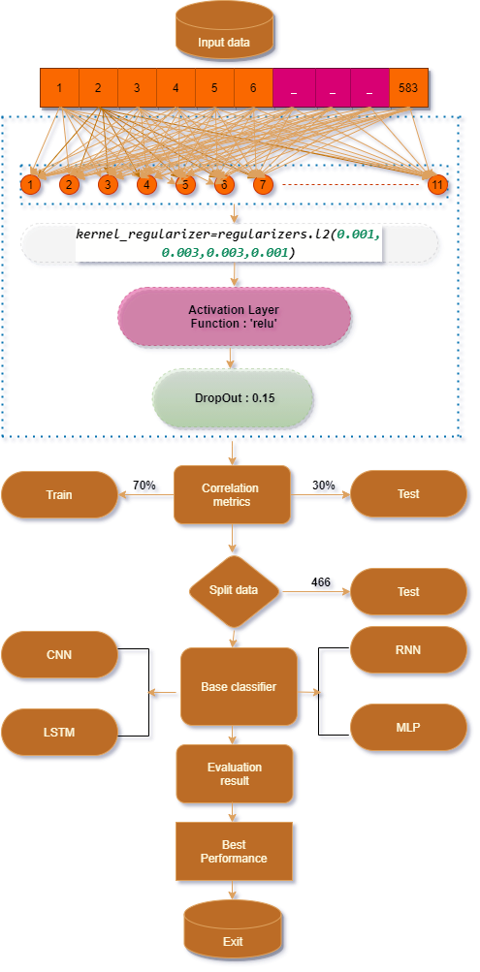

Fig. 1. Proposed Model Step By Step Procedure

1) **Input Data:** In this research work with 583 data. Where

11 attributes are observable and then all of them are floating data.

This data was collected from UCI Machine learning

repository.

2) **Correlation Metrics** In fig 2, correlation metrics are

shown

3) **Split Data:** In this research 70% data use for train model

and 30% data use for testing purpose.

4) **Basic Classifier:** Long Short Term Memory Networks, Convolutional Neural Network are used.

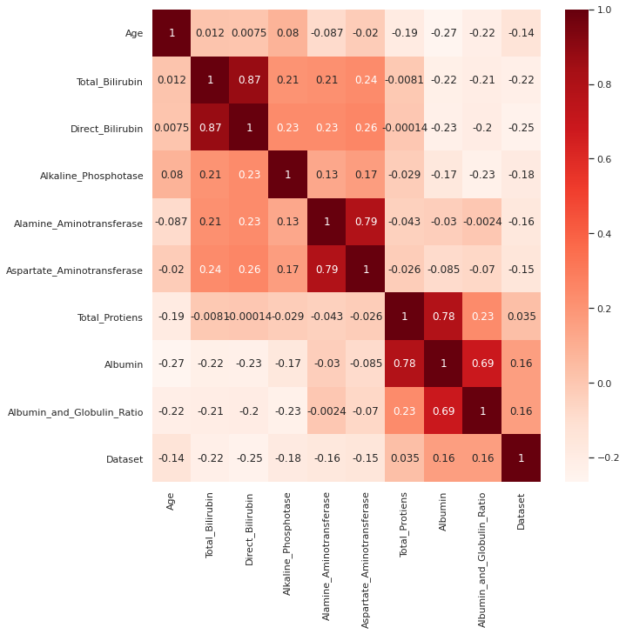

Fig. 2. Correlation metrics

5) **Evaluation Result:** In the classification report we are able to find out the confusion matrix, precision, recall and many result are shown for all algorithms

5) **Best Algorithm:** In this analysis the result depends on some part of this research. However, which algorithm gives the best true positive, false positive, true negative, and false negative are the best algorithms in this analysis.

# Result Discussion and analysis:

**Results:** In this research table I represent the confusion matrix of applying classifier. The best result shown in LSTM and CNN for sequence classification in the IMDB dataset

Long Short Term Memory Networks and Convolutional Neural Networks (LSTMs). In table II classification result are performed. The Precision, recall, f measure, and AUC (area under curve) are analysis here.

* **Precision**: Precisions in the fraction of records obtained that are important to the field of information retrieval. For eg, the number returned in a text search on a collection of documents is precise.
* **Recall:** Recall is a fraction of the related records which are effectively collected while obtaining information. For ex: the number of correct results divided by the number of results to be retrieves is recalled for a text search of a collection of documents.
* **F measure:** The F-score or F-measure is a measure of the accuracy of a test in the statistical study of the binary classification.
* **AUC:** In all practicable classification threshes, the AUC offers a detailed measure of success. One of the ways AUC can be viewed is that the model ranks higher than a random negative random positive.

The accuracy, f-1 score, precision, area under curve (AUC), and recall value of the classifiers for the testing dataset are shown in TABLE II exhibits that the best accuracy has been shown by Long Short Term Memory Networks (LSTM). It has achieved an accuracy of 85%.



Applying classifier confusion metrics analysis.

|  |  |  |  |  |
| --- | --- | --- | --- | --- |
| **Model Name** | **Accuracy(%)** | **Label** | **Prediction Negative** | **Prediction Positive** |
| **LSTM** | **87** | **Actual Negative**  **Actual Positive** | **19** | **6** |
| **Adam** | **74** | **Actual Negative**  **Actual Positive** | **0**  **1** | **12**  **0** |
| **Adamax** | **75** | **Actual Negative**  **Actual Positive** | **0**  **33** | **33**  **0** |
| **CNN** | **78** | **Actual Negative**  **Actual Positive** |  |  |
| **MLP** | **50** | **Actual Negative**  **Actual Positive** | **12**  **10** | **89**  **12** |

TABLE II

Applying classifier Result analysis.

|  |  |  |  |  |  |
| --- | --- | --- | --- | --- | --- |
| **Model Name** | **Class** | **Precision(%)** | **Recall**  **(%)** | **F1-score avg(%)** | **Accuracy(%)** |
| **LSTM** | **0**  **1** | **89**  **87** | **87**  **90** | **88**  **89** | **88** |
| **Adam** | **0**  **1** |  |  |  | **74** |
| **Dense** | **0**  **1** | **36**  **53** | **50**  **78** | **42**  **61** | **78** |
| **CNN** | **0**  **1** |  |  |  | **79** |
| **MLP** | **0**  **1** | **89**  **87** | **87**  **90** | **88**  **89** | **50** |

# Conclusion:

In this research analysis the liver disease possibility performance are shown. The performance analysis have figure out various categories such as confusion metrics, precision, recall, f measure, and auc. In overall performance Long Short Term Memory Networks (LSTMs) gives the best accuracy from other, and its accuracy is 88%. Some deep learning technique are perform to figure out best performance from our dataset. In future this study will be added machine learning and artificial intelligent method to analysis and predict liver disease possibility. Also added more data as needed.

##### References

1. Okanoue, T., Shima, T., Mitsumoto, Y., Umemura, A., Yamaguchi, K., Itoh, Y., Yoneda, M., Nakajima, A., Mizukoshi, E., Kaneko, S. and Harada, K., 2021. Artificial intelligence/neural network system for the screening of nonalcoholic fatty liver disease and nonalcoholic steatohepatitis. *Hepatology Research*, *51*(5),pp.554-569.
2. Constantinescu, E.C., Udriștoiu, A.L., Udriștoiu, Ș.C., Iacob, A.V., Gruionu, L.G., Gruionu, G., Săndulescu, L. and Săftoiu, A., 2021. Transfer learning with pre-trained deep convolutional neural networks for the automatic assessment of liver steatosis in ultrasound images. *Medical Ultrasonography*, *23*(2), pp.135-139.
3. Hectors, S.J., Kennedy, P., Huang, K.H., Stocker, D., Carbonell, G., Greenspan, H., Friedman, S. and Taouli, B., 2021. Fully automated prediction of liver fibrosis using deep learning analysis of gadoxetic acid–enhanced MRI. *European Radiology*, *31*(6), pp.3805-3814.
4. Phan, D.V., Chan, C.L., Li, A.H.A., Chien, T.Y. and Nguyen, V.C., 2020. Liver cancer prediction in a viral hepatitis cohort: A deep learning approach. *International Journal of Cancer*, *147*(10), pp.2871-2878.
5. Pati, G., Singh, A., Narayan, J., Behera, M., Sahu, M., Mishra, D., Agarwal, S. and Kar, C., 2020. Liver cirrhosis and concomitant gastric Helicobacter Pylori infection. *Microbes and Infectious Diseases*.
6. Han, A., Byra, M., Heba, E., Andre, M.P., Erdman Jr, J.W., Loomba, R., Sirlin, C.B. and O’Brien Jr, W.D., 2020. Noninvasive diagnosis of nonalcoholic fatty liver disease and quantification of liver fat with radiofrequency ultrasound data using one-dimensional convolutional neural networks. *Radiology*, *295*(2), pp.342-350.
7. Arjmand, A., Angelis, C.T., Tzallas, A.T., Tsipouras, M.G., Glavas, E., Forlano, R., Manousou, P. and Giannakeas, N., 2019, July. Deep learning in liver biopsies using convolutional neural networks. In *2019 42nd International Conference on Telecommunications and Signal Processing (TSP)* (pp. 496-499). IEEE.
8. Dandan, L., Huanhuan, M., Xiang, L., Yu, J., Jing, J. and Yi, S., 2019, May. Classification of diffuse liver diseases based on ultrasound images with multimodal features. In *2019 IEEE International Instrumentation and Measurement Technology Conference (I2MTC)* (pp. 1-5). IEEE.
9. Cao, W., An, X., Cong, L., Lyu, C., Zhou, Q. and Guo, R., 2020. Application of Deep Learning in Quantitative Analysis of 2‐Dimensional Ultrasound Imaging of Nonalcoholic Fatty Liver Disease. *Journal of Ultrasound in Medicine*, *39*(1), pp.51-59.
10. Reddy, D. Santhosh, R. Bharath, and Pachamuthu Rajalakshmi. "A novel computer-aided diagnosis framework using deep learning for classification of fatty liver disease in ultrasound imaging." In *2018 IEEE 20th International Conference on e-Health Networking, Applications and Services (Healthcom)*, pp. 1-5. IEEE, 2018.
11. Yao, Z., Li, J., Guan, Z., Ye, Y. and Chen, Y., 2020. Liver disease screening based on densely connected deep neural networks. *Neural Networks*, *123*, pp.299-304.
12. [**https://www.geeksforgeeks.org/image-classifier-using-cnn/**](https://www.geeksforgeeks.org/image-classifier-using-cnn/)
13. <https://www.youtube.com/watch?v=BSpXCRTOLJA>
14. https://machinelearningmastery.com/time-series-prediction-lstm-recurrent-neural-networks-python-keras/
15. Olmedo, M.T.C., Paegelow, M., Mas, J.F. and Escobar, F. eds., 2018. *Geomatic approaches for modeling land change scenarios*. Springer International Publishing.
16. Emon, M.U., Keya, M.S., Meghla, T.I., Rahman, M.M., Al Mamun, M.S. and Kaiser, M.S., 2020, November. Performance Analysis of Machine Learning Approaches in Stroke Prediction. In *2020 4th International Conference on Electronics, Communication and Aerospace Technology (ICECA)* (pp. 1464-1469). IEEE.
17. Islam, M.A., Islam, M.S., Hossen, M.S., Emon, M.U., Keya, M.S. and Habib, A., 2020, November. Machine Learning based Image Classification of Papaya Disease Recognition. In *2020 4th International Conference on Electronics, Communication and Aerospace Technology (ICECA)* (pp. 1353-1360). IEEE.
18. Keya, M.S., Shamsojjaman, M., Hossain, F., Akter, F., Islam, F. and Emon, M.U., 2021, March. Measuring the Heart Attack Possibility using Different Types of Machine Learning Algorithms. In *2021 International Conference on Artificial Intelligence and Smart Systems (ICAIS)* (pp. 74-78). IEEE.